5-Year Merger Review for Denver, Colorado
On February 1, 2017, Vivent Health completed a first of its kind merger with Rocky Mountain Cares (RMC) of Denver, Colorado. RMC provided case management, prevention, and pharmacy services with strategic plans to expand operations. Unfortunately, RMC realized it would take as long as 10 years to meet its goals.
The RMC and Vivent Health Boards of Directors and leadership teams together determined that a partnership via merger would significantly accelerate the proposed expansion of care to people affected by HIV in Denver.
In Denver, Vivent Health now has a fully operational HIV Medical Home in a new 25,000 square foot facility that offers integrated health and social services. Upon the 5-year anniversary of the merger goals have been exceeded in four key areas: Champions, Access, Quality and Finance.

Expanding Colorado Champions
Champion headcount has grown by more than 350% in the first 5 years since merger. Employing more individuals is only part of the story. We have been able to attract talented, experienced individuals for all the Medical Home services including physicians, nurse practitioners, nurses, dentists and hygienists, pharmacists, pharmacy technicians, and behavioral health therapists for our health operations. Our social services are provided by attorneys, nutritionists, medical and community case managers, insurance specialists and experienced prevention staff.
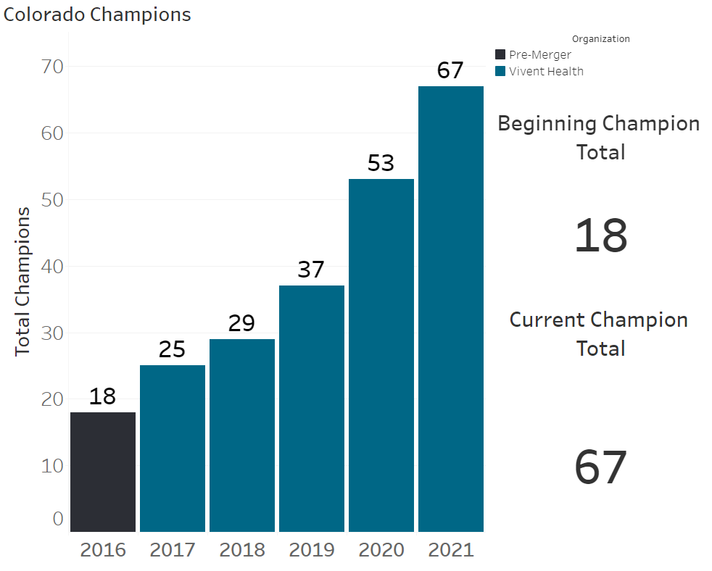

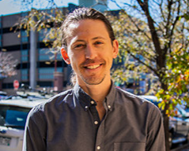
“I was thrilled to have been part of the first out-of-state merger with Vivent Health. It was a very exciting time for us in Colorado five years ago as we joined forces with an organization that was expanding the integrated medical home model of care into other states. I saw first-hand the impact of organizations coming together to best serve the patients and clients that turn to us for their care and services. The impact of change and the chance to learn from one another has helped us grow. We have grown so much in these 5 years! I have loved having opportunities to collaborate with Champions across the country, and I look forward to what lies ahead for Vivent Health and our efforts in continuing to best serve the communities that we intrinsically care for.”

JC Goodhart, LSW
Director of Social Services
Vivent Health - Denver, Colorado
Increasing Access to Care
Vivent now serves over 3,000 patients and clients in Denver. This represents a three-fold increase in people who that are receiving care through our services. Currently, 40% of the people we care for are uninsured or underinsured. Vivent Health is now the largest HIV care provider in Denver.
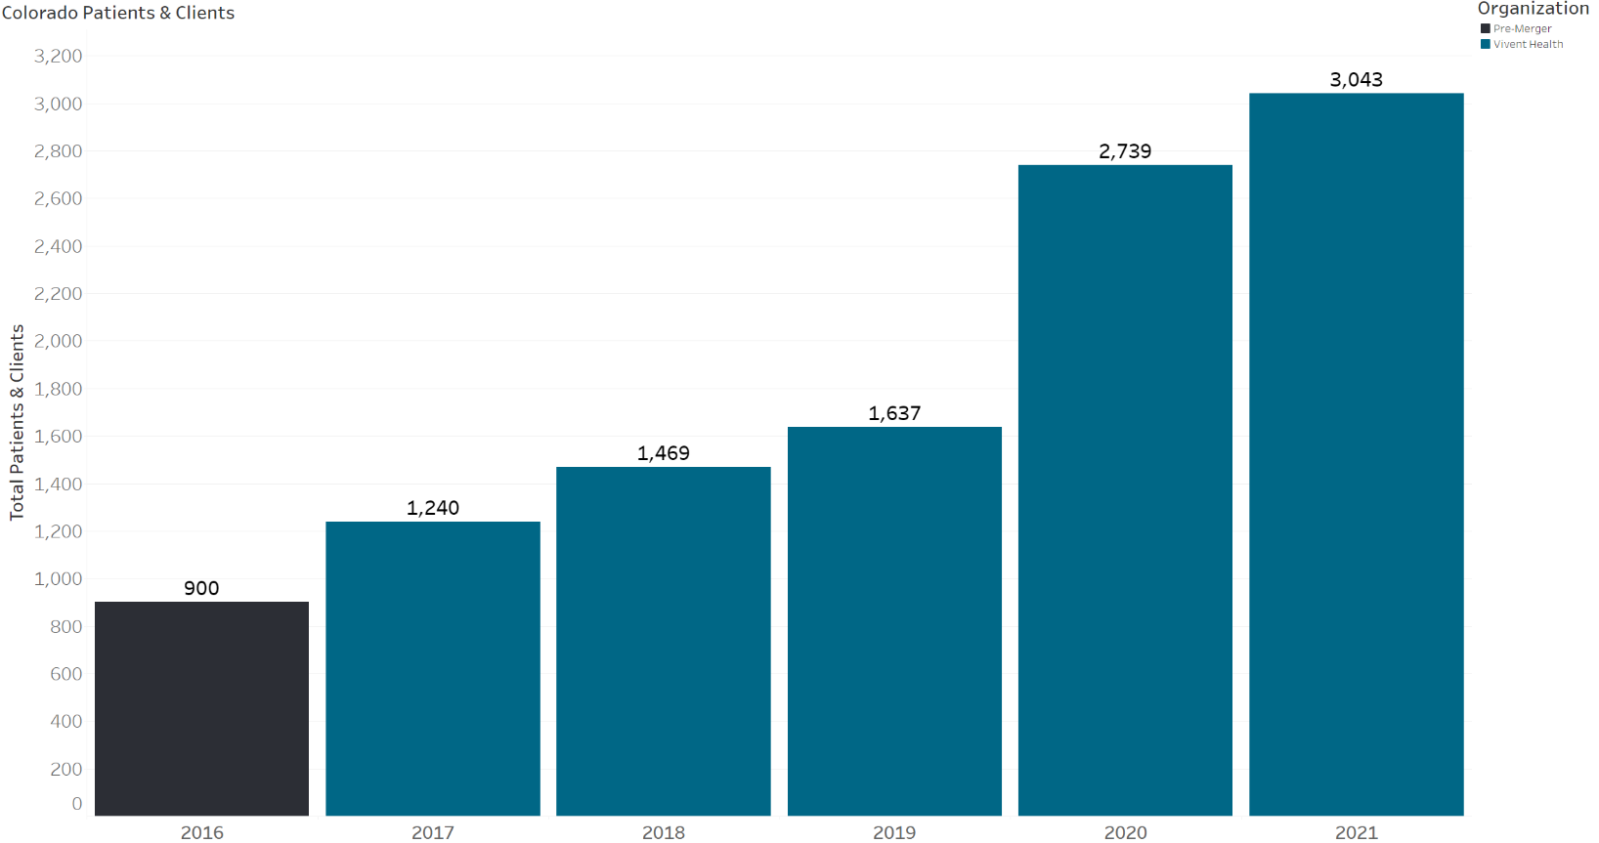

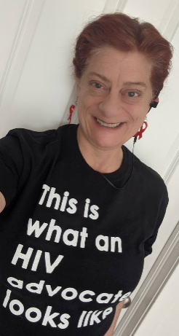
“In a world where people living with HIV can often live long and healthy lives, medical care is critical. Vivent Health moves beyond providing exceptional healthcare to support all their patients’ needs and continually advocates for policies and regulations that support the dignity, and holistic wellbeing of people living with HIV and communities which are vulnerable to HIV.

As we strive to ensure that Colorado is a welcoming place for everyone by ensuring healthcare, access to necessary services, addressing combatting HIV stigma and discrimination, supporting diverse community needs and removing health disparities that continue to drive the HIV epidemic, we know that Vivent Health and their staff will be a part of this work and in community with us.”

Barb Cardell, person living with HIV
Legislative Chair – CORA – Colorado Organizations and Individuals Responding to HIV/AIDS
Co-Founder Positive Women’s Network - Colorado
Improving Quality & Reducing Racial Disparities
Providing high quality healthcare is our top priority. The most important measure of quality HIV care is achieving and undetectable viral load. Since merging with RMC, Vivent Health has steadily increased the number of patients who are undetectable to 95% Quality must be achieved for all patients, regardless of race. The national average for racial disparity in HIV patients with an undetectable viral load is upwards of 15%. Prior to merger RMC was at 16.7%. Today, after 5 years, we have significantly reduced disparity in health outcomes for people of color in Denver.
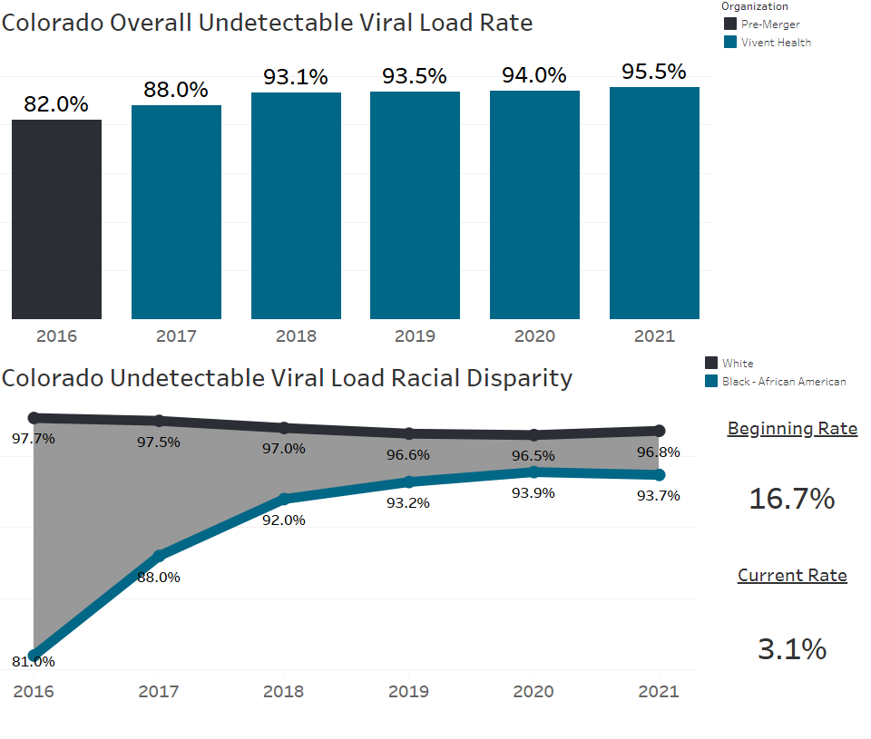


“Five years ago, the Board of Rocky Mountain CARES took a calculated risk and merged with Vivent Health. We did so because we believed this was the best option for securing continued service and expanding care for our patients and clients.

The merger went beyond what we aspired to - Vivent Health has not only allowed us to reach more people in need but also to greatly expand the services we offer while providing our patients clients with exceptional, high quality, integrated care through our medical home model and all at one site. I have been so impressed we’ve kept the local, patient focus. ”

Christopher Price
Consultant International Community Development
Former Board Member of Rocky Mountain Cares and Vivent Health
Investing Now and in the Future
Financial success is a key component for the Medical Home model of care. HIV is a chronic condition, and people diagnosed today will need care for decades to come. Our patients need to be able to depend on Vivent Health to be around for their care. Revenue and operating margin increases allow us to sustain and expand care and treatment. Since our merger, we have increased annual revenue $50 million; from $5 to $56 million. Part of this increase comes from public and private grant funders that were initially skeptical about the merger. Over 5 years, this skepticism has turned into enthusiastic support. Funding for Vivent Health in Denver from state, local and private funders has increased 8 fold
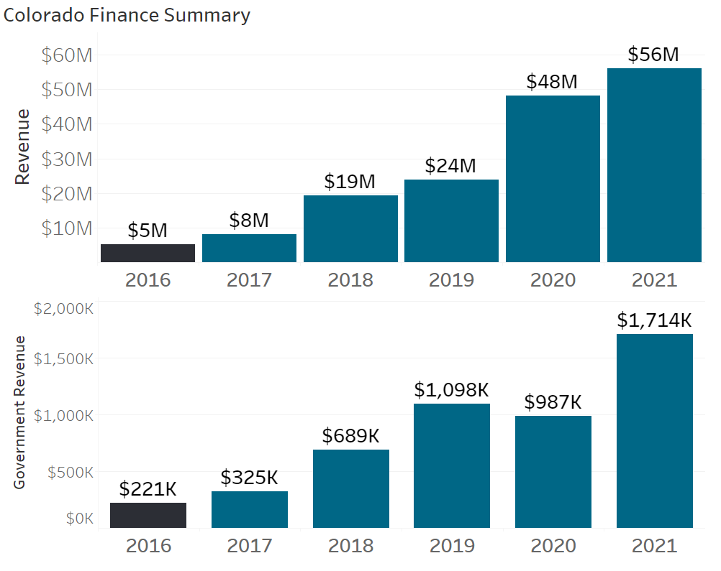


"I am excited to celebrate our 5-year anniversary at Vivent Health Denver. During these wonderful 5 years we were able to increase the number of people that we serve through our investment in our Medical Home model. We’re thrilled to be expanding our HOPWA (Housing Opportunities for Persons with AIDS) services with a new grant, validating our work in this community. It is very exciting to think about the future and the great services we will continue to provide through our Medical Home. I am looking forward to the next 5 years and beyond."

James Greer
Senior Vice President of Operations
Vivent Health – Denver, Colorado

